TASK - 2

INSTAGRAM USER ANALYTICS

# Project Description:

In this project, we need to peruse the given data and information in order to help find the solutions for the given situations. The problems elaborate various situations that may arise while analyzing data that is generated by Instagram users in a particular period of time. The project involves multiple tables namely “users”, “comments”, “follows”, “likes”, “photo_tags”, “photos”, “tags” which belong to the same dataset: “ig_clone”. Clearly, the dataset is generated by cloning the data generated by Instagram. Here, we refer to these situations as queries. I look forward to using SQL commands to find appropriate answers for these queries. We utilize a software called “MySQL” as it provides us an interface to run and execute the SQL commands. This project helps in building a strong foundation or base for the journey of DataBase Management using SQL.

# Approach:

The problems are based on two main categories which are: “Marketing” and “Investor metrics”. Since all of them are independent of each other, the best possible way to solve all the situations is to analyze each of the given scenarios separately and build a query to solve them one after the other. This process is also called the Brute-Force approach which gives an unambiguous understanding and uninterrupted processing of the task.

# Tech Stack:

Language: Structured Query Language [S.Q.L.]

Software used: MySQL

Version: 8.0.30

Original Author: MySQL AB

Developer: ORACLE Corporation

Latest Stable Release: 6th July 2022

Purpose: To run and execute SQL Commands.

# Task/Solution:

**A) Marketing:**

1. **Rewarding Most Loyal Users:** Find the 5 oldest users of the Instagram from the database provided

Sol: Users of the Instagram from the database provided are:

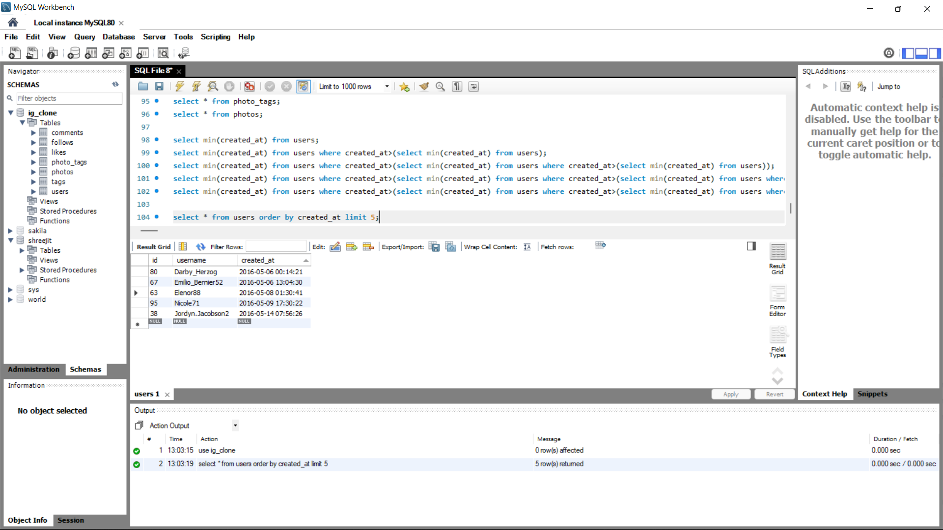

1. **Remind Inactive Users to Start Posting:** Find the users who have never posted a single photo on Instagram

Sol: Users who have never posted a single photo on Instagram are:

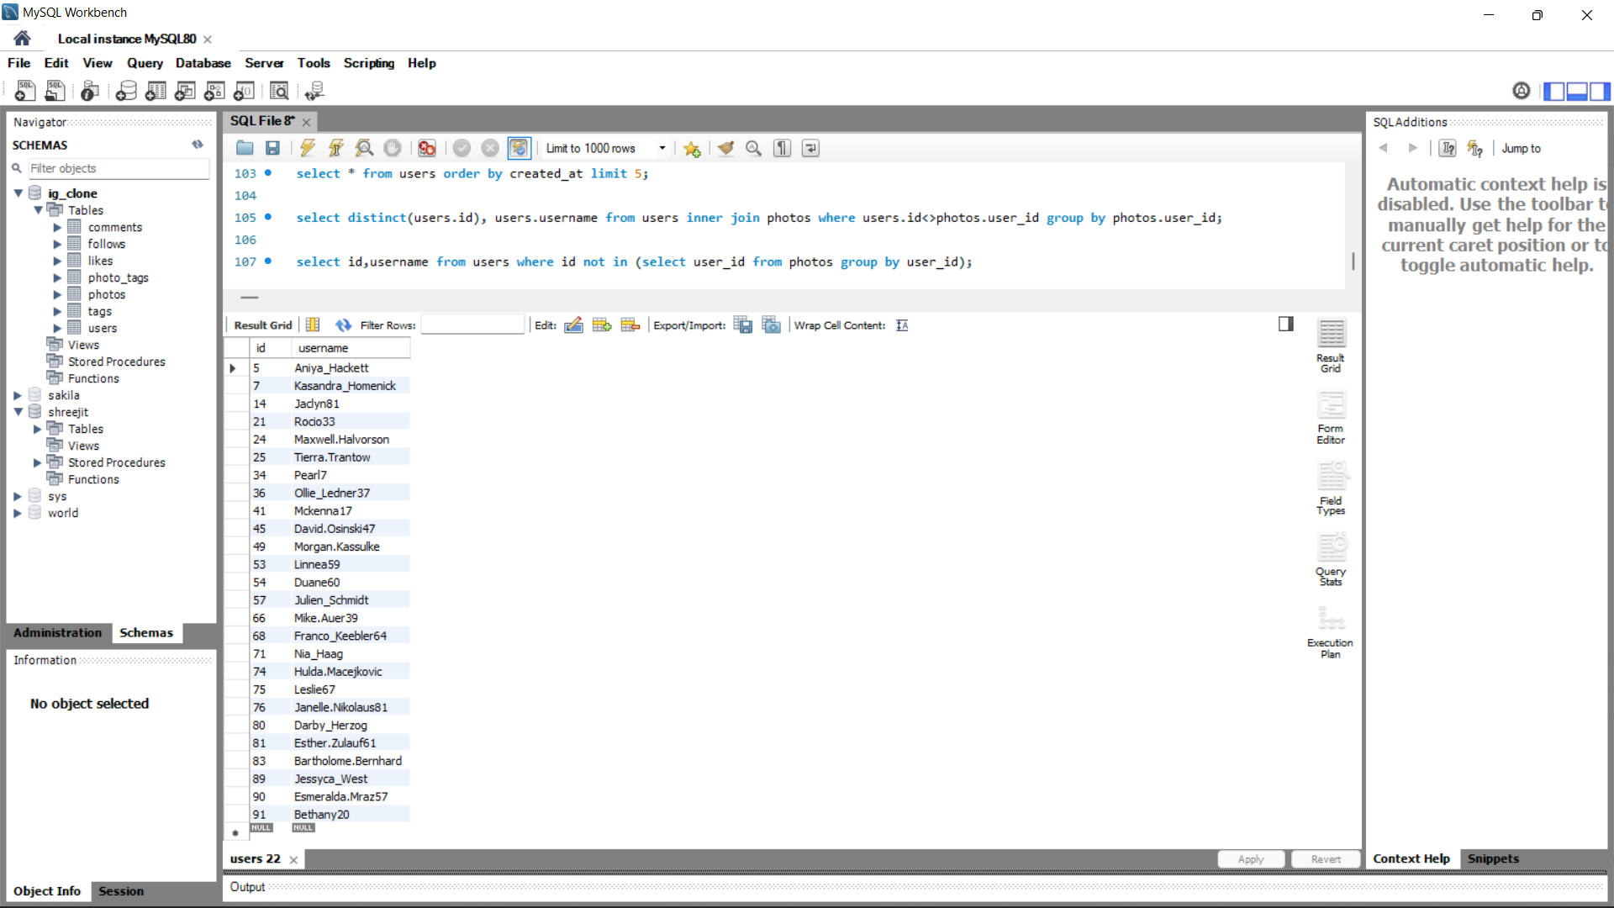

1. **Declaring Contest Winner:** The team started a contest and the user who gets the most likes on a single photo will win the contest now they wish to declare the winner. Identify the winner of the contest and provide their details to the team

Sol: **The winner of the contest is photo_id 145 with 48 likes:**

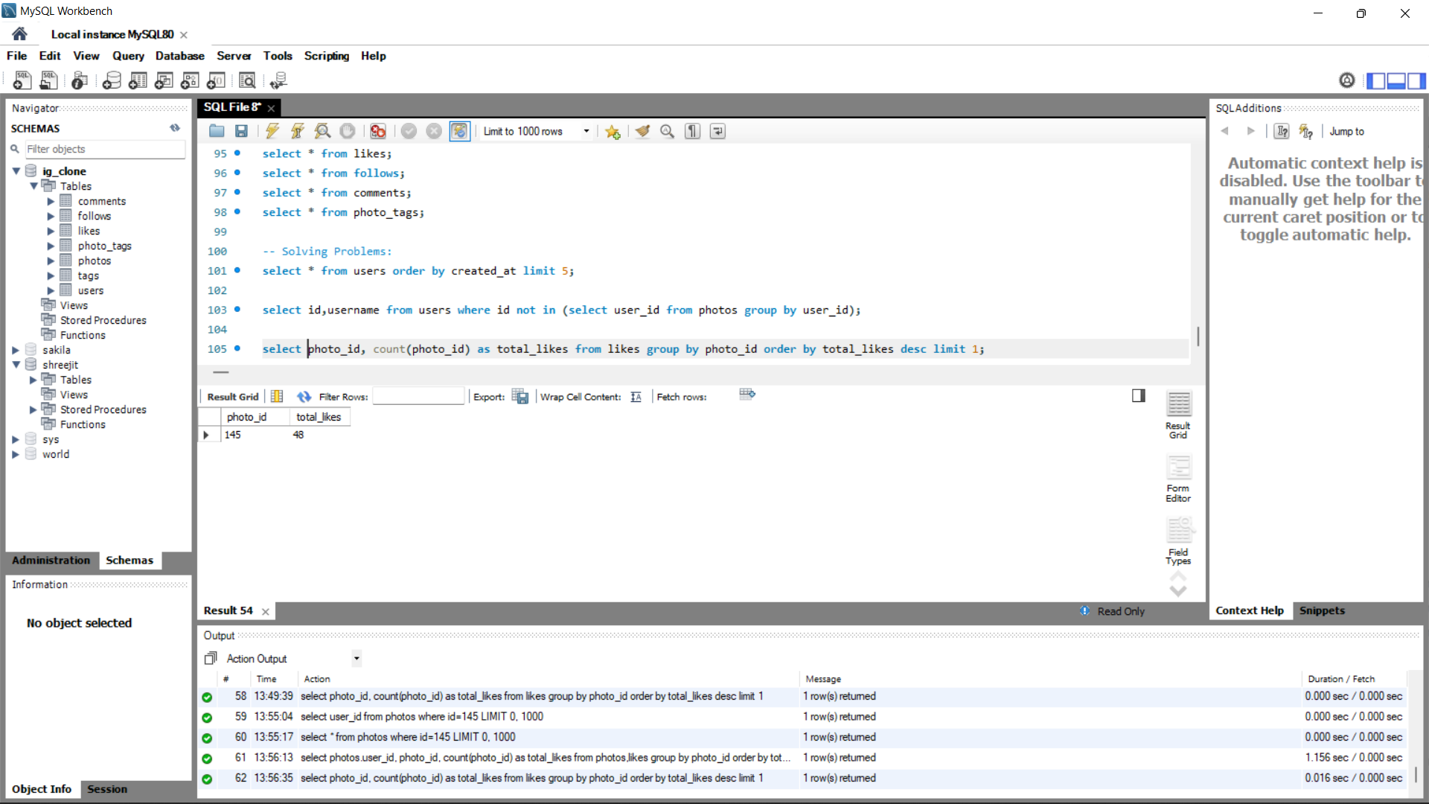

1. **Hashtag Researching:** Identify and suggest the top 5 most commonly used hashtags on the platform

Sol: The top 5 most commonly used hashtags on the platform are:

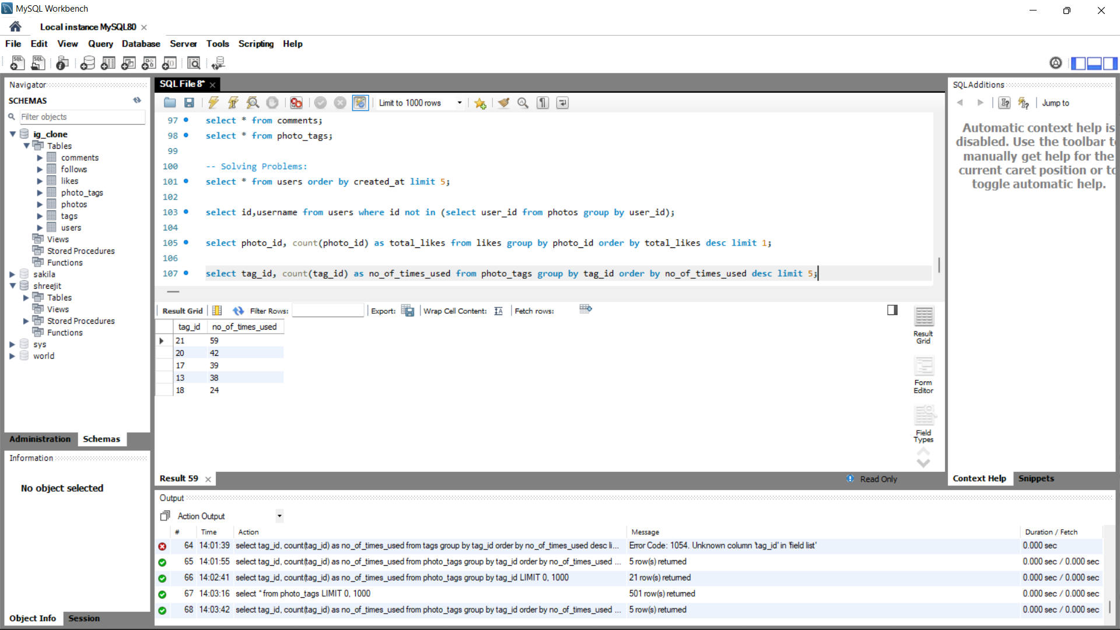

1. **Launch AD Campaign:** The team wants to know which day would be the best day to launch ADs. What day of the week do most users register on? Provide insights on when to schedule an ad campaign

Sol: The below table shows days and no. of accounts created on that day.

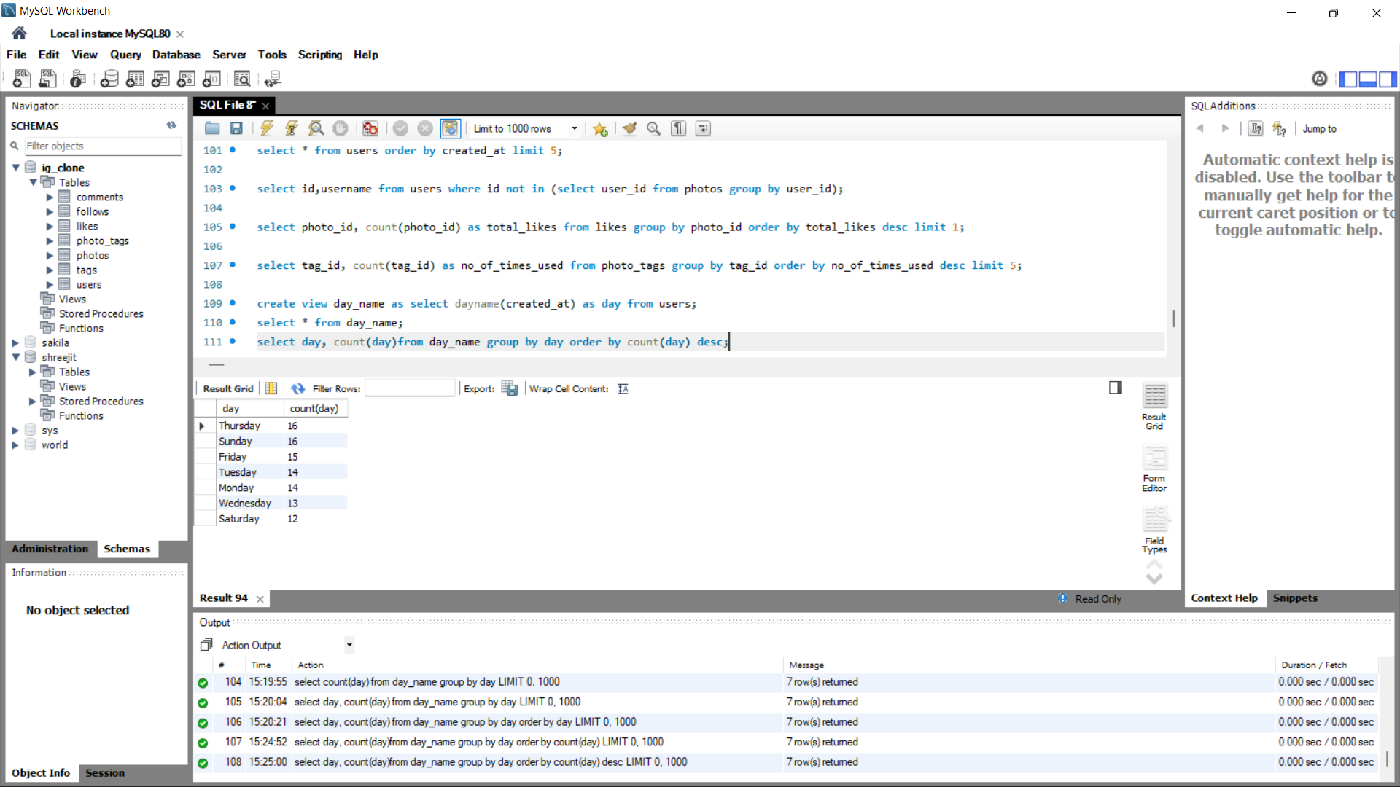

**Conclusion:** From the above table it's clear that Thursdays and Sundays have highest registrations followed by Friday. Hence the best suggested schedule for an ad campaign would be from Thursday to Sunday every week. In addition to that, the best day for launching ads would be Sunday, because users have most of their day free on Sundays which gives them more time to look through the ad.

**B) Investor Metrics:**

1. **User Engagement:** Are users still as active and post on Instagram or they are making fewer posts. Provide how many times an average user posts on Instagram. Also, provide the total number of photos on Instagram/total number of users

Sol: **i. Provide how many times an average user posts on Instagram.**

The below table shows users and number of posts they did:

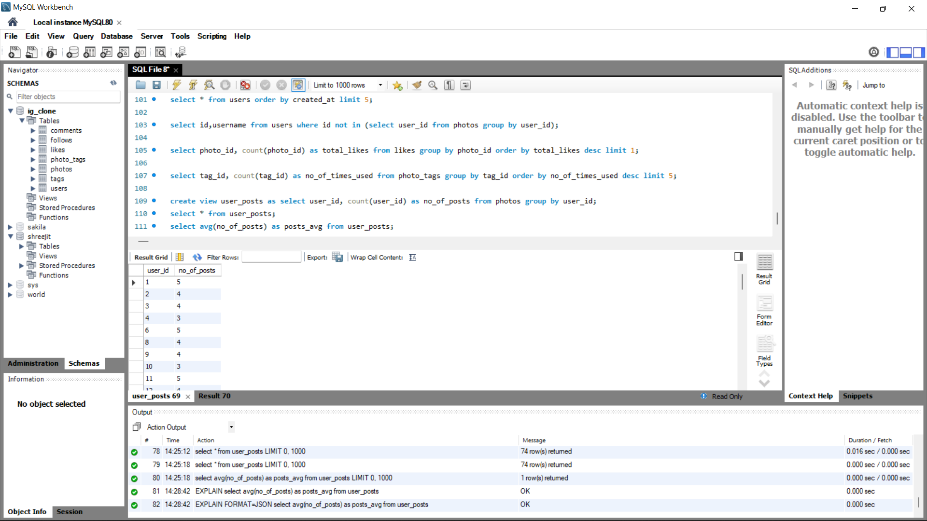

The below table shows the average number of posts made by user:

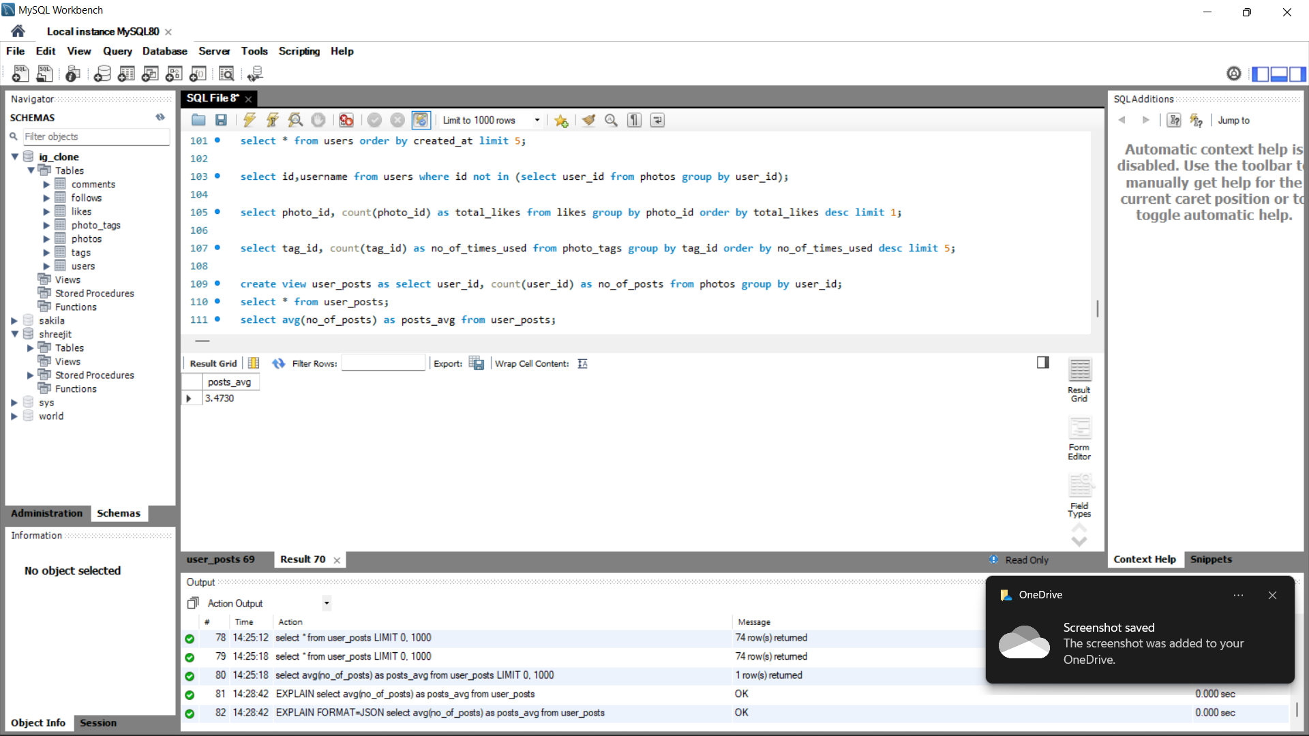

**ii. Provide the total number of photos on Instagram/total number of users:**

The below table shows the total number of photos on Instagram:

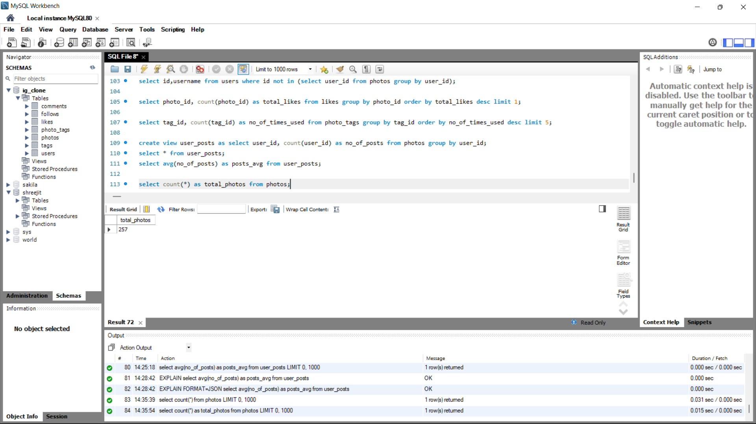

The below table shows the total number of photos on Instagram:

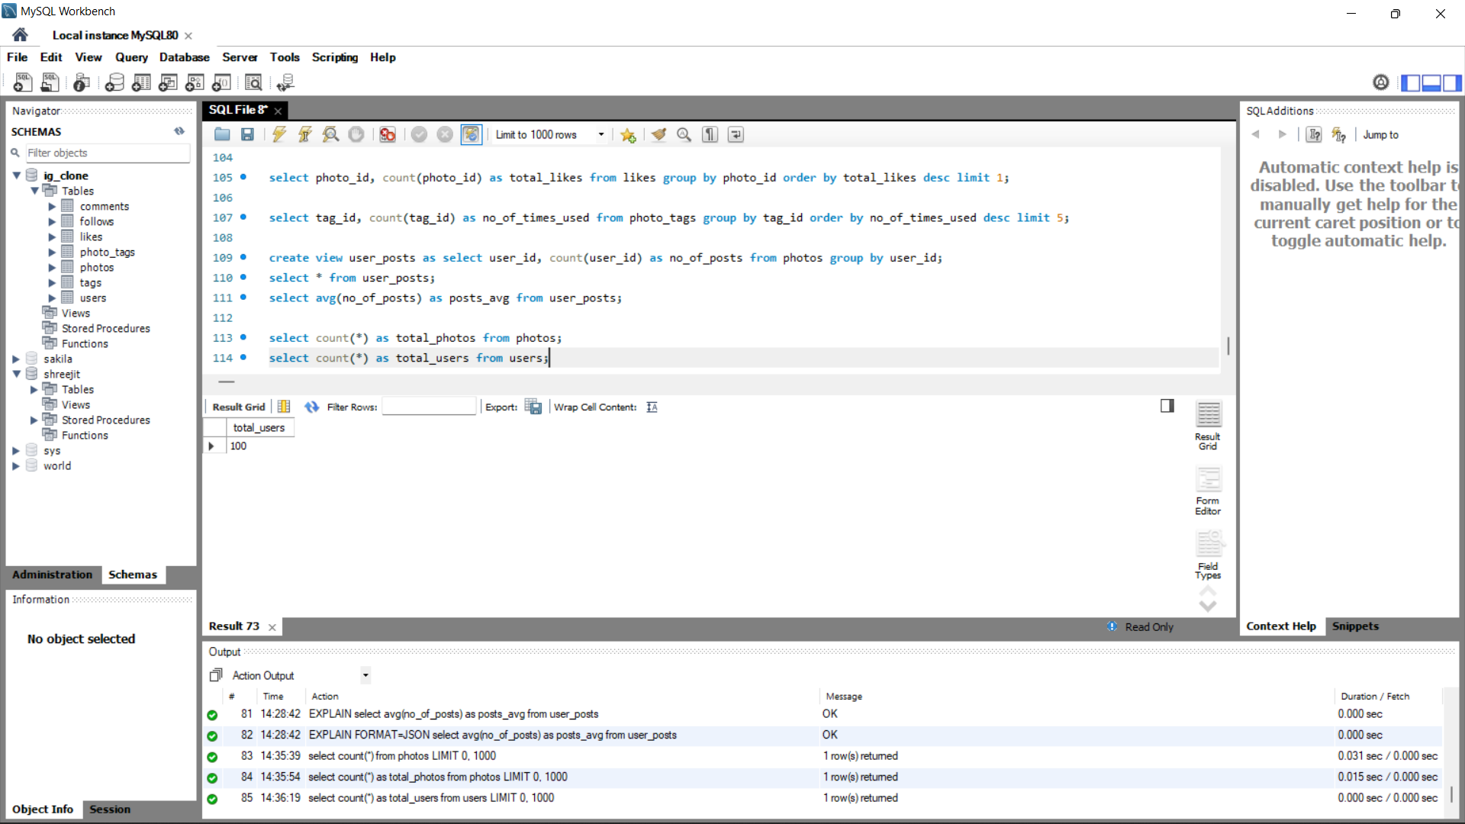

1. **Bots & Fake Accounts**: The investors want to know if the platform is crowded with fake and dummy accounts. Provide data on users (bots) who have liked every single photo on the site (since any normal user would not be able to do this).

Sol: The user(s) who liked every photo on Instagram are:

# Insights:

Insights refers to accurate understanding of something. These points helps in an insightful understanding of the problems:

* All the problems refer to real-life situations which any data analyst would face while dealing with data. The attributes may differ but the application or approach will not change.
* The given sums are broadly classified as the needs of the Marketing team and Investors who are trying to fetch information from previous data.
* Data means a series of records of values which are collected over a period of time and stored in an organized manner. When data is processed and some required value is fetched out of it then it is called Information.
* Data is stored in Databases by Data Scientists using DDL [Data Definition Language] commands and is analyzed by Data Analysts using DML [Data Manipulation Language] commands of SQL.
* SQL is a language which helps us to manage, manipulate and maintain databases, it abbreviates Structured Query Language whereas, MySQL is a software or a tool which provides a platform to run and execute SQL commands.

# Result:

To recapitulate, the results are elaborately discussed above, moreover this project/task helped me in better understanding of SQL commands and working with databases. It also enhanced my Critical Thinking and Problem-Solving skills. (I could not solve all the questions by using joins. However I managed to draw conclusions using other concepts which are hopefully right).

Thank You.